**IBM NALAIYA THIRAN PROJECT REPORT**

**Predicting the Energy Output of Wind Turbine Based On Weather Condition**

**BY TEAM MEMBERS**,

K.R.SIVA SAKTHI

R.SUBASHINI

R.VAISHNAVI

R.VIGNESGWARI

|  |  |
| --- | --- |
| Date | 17 November 2022 |
| Team ID | PNT2022TMID33022 |
| Project Name | Predicting the Energy Output Of Wind Turbine Based On Weather Condition |
| Maximum Marks | 8 Marks |

**INDEX**

**1. ABSTRACT**

**2. INTRODUCION**

**2.1 Overview**

**2.2 Machine Learning**

**3. LITERATURE SURVEY**

**3.1 Related works**

**4. SOFTWARE TOOLS**

**4.1 Software Pre-Requisites**

**5. PROJECT DESCRIPTION**

**5.1 SYSTEM ARCHITECTURE**

**5.1.1 Data Collection**

**5.1.2 Data Pre-Processing**

**5.1.3 Training with Machine Learning Models**

**5.1.4 Graphical User Interface (GUI)**

**5.2 MODULE DESCRIPTION**

**5.2.1 Prediction Module**

**5.2.2 Forecasting Module**

**6. SYSTEM IMPLEMENTATION**

**7. ADVANTAGES**

**8. RESULTS**

**9. FUTURE SCOPE**

**10. CONCLUSION**

**APPENDIX**

**ABSTRACT**

Wind power generation differs from conventional thermal generation due to the stochastic nature of wind. Thus wind power forecasting plays a key role in dealing with the challenges of balancing supply and demand in any electricity system, given the uncertainty associated with the wind farm power output. Accurate wind powerforecasting reduces the need for additional balancing energy and reserve power tointegrate wind power. For a wind farm that converts wind energy into electricity power, a real-time prediction system of the output power is significant. The objective of our project is to develop an end-to-end web application to predict and forecast the energyoutput of the wind turbine based on weather conditions. In this guided project, aprediction system is developed with a method of combining statistical models andphysical models of Machine Learning. In this system, the inlet condition of thewindfarm is forecasted by the auto regressive model

**INTRODUCTION**

**2.1 Overview**

Wind energy plays an increasing role in the supply of energy worldwide.

The energy output of a wind farm is highly dependent on the weather conditions

present at its site. We take energy prediction based on weather data and analyze the

important parameters as well as their correlation on the energy output. To deal with

the interaction of the different parameters, we use random forest regression of

machine learning algorithms. The model obtained for energy prediction gives a very

reliable prediction of the energy output for supplied weather data.

**2.2 Machine Learning**

Machine learning (ML) is a field of inquiry devoted to understanding and

building methods that 'learn', that is, methods that leverage data to improve

performance on some set of tasks. Machine learning algorithms build a model based

on sample data, known as [training data](https://en.wikipedia.org/wiki/Training_data), in order to make predictions or decisions

without being explicitly programmed to do so. In [statistical modeling](https://en.wikipedia.org/wiki/Statistical_model), regression

analysis is a set of statistical processes for [estimating](https://en.wikipedia.org/wiki/Estimation_theory) the relationships between

a [dependent variable](https://en.wikipedia.org/wiki/Dependent_variable) and one or more [independent variables](https://en.wikipedia.org/wiki/Independent_variable). Regression analysis is

primarily used for two conceptually distinct purposes.First, regression analysis is

widely used for [prediction](https://en.wikipedia.org/wiki/Prediction) and [forecasting](https://en.wikipedia.org/wiki/Forecasting), where its use has substantial overlap with

the field of [machine learning](https://en.wikipedia.org/wiki/Machine_learning).Second, in some situations regression analysis can be

used to infer [causal relationships](https://en.wikipedia.org/wiki/Causality) between the independent and dependent variables.

**LITERATURE SURVEY**

3.1 Related works

1.The State-Of-The-Art in Short-Term Prediction of Wind Power

**Author: Gregor Giebel**

  This report will give an overview over past and present attempts to predict wind power for single turbines or for whole regions, for a few minutes or a few days ahead. It has been produced for the ANEMOS project [1], which brings together many groups from Europe involved in the field, with up to 15 years of experience in short-term forecasting. The literature search involved has been extensive, and it is hoped that this report can serve as a reference for all further work. One of the largest problems of wind power, as compared to conventionally generated electricity, is its dependence on the volatility of the wind. This behaviour happens on all time scales, but two of them are most relevant: One is for the turbine control itself (from milliseconds to seconds), and the other one is important for the integration of wind power in the electrical grid, and therefore determined by the time constants in the grid (from minutes to weeks).

 2.Validations on wind power plant models

**Authors:  E Muljadi , A Ellis**

   Wind energy will continue to grow at a rapid pace and will provide an increasingly large portion of the total electricity generation. To achieve its full potential, the industry needs adequate wind-turbine generator (WTG) dynamic models to determine the impact of adding wind generation, and establish how the system needs to be upgraded .For the most part, WTG manufacturers have sponsored the development of WTG dynamic models. Models developed under this paradigm tend to be proprietary and specific to a particular WTG model. They often disclosed under confidential terms for interconnection studies and design of individual projects. However, once the projects are installed, the use of proprietary models is incompatible with critical grid planning activities that are conducted by regional reliability organizations as a collaborative effort among many stakeholders.

3.Forecasting of Wind Turbine Output Power Using Machine learning

**Authors: Haroon Rashid, Waqar Haider, Canras Batunlu**

             Most of the countries around the world are facing huge environmental impact, and the most promising solution to mitigate these is the use of renewable energy, especially wind power. Though, the use of offshore wind energy is rapidly increasing to meet the elevating electricity demand. The researchers and policymakers have become aware of the importance of providing near accurate prediction of output power. Wind energy is tied to variabilities of weather patterns, especially wind speed, which are irregular in climates with erratic weather conditions. In this paper, we predicted the output power of the wind turbines using the random forest regressor algorithm.The SCADA data is collected for two years from a wind farm located in France. The model is trained using the data from 2017.

4.Integrative Density Forecast and Uncertainty Quantification of Wind Power Generation

**Authors: Jingxing Wang, Abdullah Alshelahi, Mingdi You, Eunshin Byon, and Romesh Saigal**

The volatile nature of wind power generation creates challenges in achieving secure power grid operations. It is, therefore, necessary to accurately predict wind power and its uncertainty quantification. Wind power forecasting usually depends on wind speed prediction and the wind-to-power conversion process. However, most current wind power prediction models only consider portions of the uncertainty. This paper develops an integrative framework for predicting wind power density, considering uncertainties arising from both wind speed prediction and the wind-to-power conversion process. Specifically, we model wind speed using the inhomogeneous Geometric Brownian Motion and convert the wind speed prediction into the wind power density in a closed-form. The resulting wind power density allows quantifying prediction uncertainties through prediction intervals. To forecast the power output, we minimize the expected prediction cost with (unequal) penalties on the overestimation and underestimation. We show the predictive power of the proposed approach using data from multiple operating wind farms located at different sites.

5.Predicting The Energy Output Of Wind Turbine Based On Weather Condition:

**Authors: S Preethi, H Prithika, M Pramila, S Birundha**

Extracting electricity from renewable resources has been widely investigated in the past decades to decrease the worldwide crisis in the electrical energy and environmental pollution. For a wind farm which converts the wind power to electrical energy, a big challenge is to predict the wind power precisely in spite of the instabilities. The climatic conditions present in the site decides the power output of a wind farm. As the schedule of wind power availability is not known in advance, this causes problems for wind farm operators in terms of system and energy planning. A precise forecast is required to overcome the difficulties initiated by the fluctuating weather conditions. If the output is forecasted accurately, energy providers can keep away costly overproduction. In this paper, an end-to-end web application has been developed to predict and forecast the wind turbine's power generation based on the weather condition.

**SOFTWARE TOOLS**

**4.1 Software Pre-Requisites**

**Anaconda Navigator:**

Anaconda Navigator is a free and open-source distribution of the Python and R programming languages for data science and machine learning related applications. It can be installed on Windows, Linux, and macOS. Conda is an open-source, cross-platform, package management system.



Anaconda comes with great tools like JupyterLab,Jupyter Notebook, QtConsole, Spyder, Glueviz, Orange, Rstudio, Visual Studio Code.

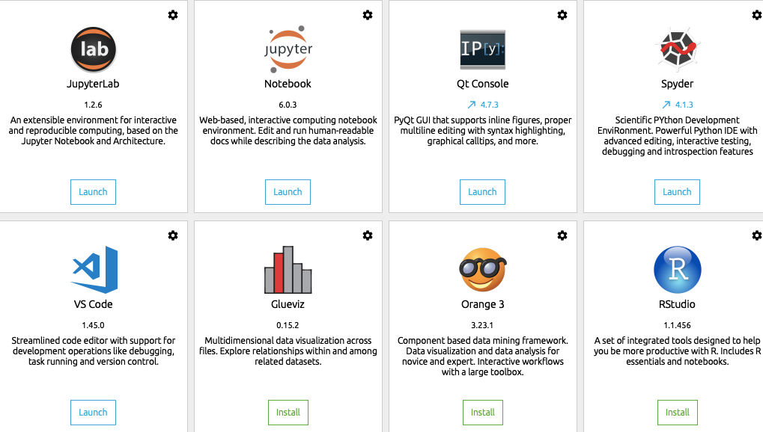

**Jupyter Notebook:**

The Jupyter Notebook is the original web application for creating and sharing computational documents. It offers a simple, streamlined, document-centric experience.



**Spyder:**

Spyder is a free and open source scientific environment written in Python, for Python, and designed by and for scientists, engineers and data analysts.



**Packages Needed:**

**Sklearn:**  Scikit-learn is a library in Python that provides many unsupervised and supervised learning algorithms.  
 

**NumPy:**  NumPy is a Python package that stands for 'Numerical Python'. It is the core library for scientific computing, which contains a powerful n-dimensional array object .   
 

**Pandas:**Pandas is a fast, powerful, flexible, and easy to use open-source data analysis and manipulation tool, built on top of the Python programming language.    
 

**Matplotlib:** It provides an object-oriented API for embedding plots into applications using general-purpose GUI toolkits.

**Flask:** Web framework used for building Web applications.   
 

**PROJECT DESCRIPTION**

**5.1 SYSTEM ARCHITECTURE**

The models operating on the production server would work with the real-life data and provide predictions to the users.The below mentioned framework represents the most basic way of handling the project using Machine Learning model.

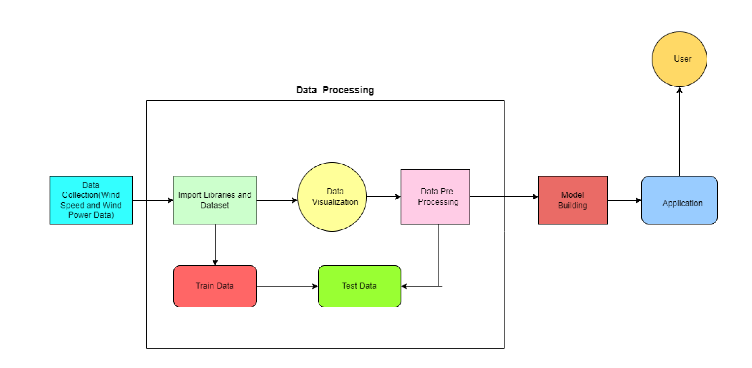

**5.1.1 Data Collection**

ML depends heavily on data, without data a machine can't learn. It is the most crucial aspect that makes algorithm training possible. In Machine Learning projects, we need a training data set. It is the actual data set used to train the model for performing various actions. The dataset which is considered here will have the environmental conditions. The dataset contains the details about tempstamp, air temperature (deg Celcius), pressure (atm), wind direction (deg), wind speed (m/s) and Power generated by the system (kW).

**5.1.2 Data Pre-Processing**

Data Pre-Processing is a step-by-step process that includes following processes:

1. Processing the dataset.
2. Handling the null values.
3. Handling the categorical values if any.
4. Normalize the data if required.
5. Identify the dependent and independent variables.
6. Split the dataset into train and test sets.

**5.1.3 Training with Machine Learning**

There are several Machine learning algorithms to be used depending on the data you are going to process such as images, sound, text, and numerical values. The algorithms can be chosen according to the objective. As the dataset which we are using is a Regression dataset so you can use the following algorithms

* Linear Regression
* Random Forest Regression / Classification
* Decision Tree Regression / Classification

Here, in this project we used Random Forest Regression algorithm. Train the Machine Learning models with different sets of processed data. Finally select the model that gives maximum of accuracy.

**5.1.4 Graphical User Interface (GUI)**

The GUI , graphical user interface, is a form of [user interface](https://en.wikipedia.org/wiki/User_interface) that allows [users](https://en.wikipedia.org/wiki/User_(computing)) to [interact with electronic devices](https://en.wikipedia.org/wiki/Human%E2%80%93computer_interaction) through graphical [icons](https://en.wikipedia.org/wiki/Icon_(computing)) and audio indicator such as primary notation, instead of [text-based UIs](https://en.wikipedia.org/wiki/Text-based_user_interface), typed command labels or text navigation. GUIs were introduced in reaction to the perceived steep [learning curve](https://en.wikipedia.org/wiki/Learning_curve) of CLIs ([command-line interfaces](https://en.wikipedia.org/wiki/Command-line_interface)), which require commands to be typed on a [computer keyboard](https://en.wikipedia.org/wiki/Computer_keyboard).

A easy and simple way to understand the interface which designed for users to know the future wind power updates. For predicting the power output for user defined values, user just needs to input the weather parameters for which the power is to be predicted.

**5.2 Module Description**

* + 1. **Prediction Module**
* The power output predicted according to the users defined values.
* User just needs to give the input for weather parameters for which the power is to be predicted.
* We train our model with the historic data.
* Then we can feed a new weather data according to the user’s input and predict the power output.
  + 1. **Forecasting Module**
* Forecasting the power output of wind turbine from several hours up to 48 hours ahead.
* User can input their location to know the weather predictions.
* According to this, wind power can be predicted and forecasting takes place.
* With minimum loading time, accurate results can be obtained.

**SYSTEM IMPLEMENTATION**

Our project is based on Machine Learning model. This is implemented with the help of Python language. Here Anaconda Navigator is used as it comes with the great tools like JupyterNotebook, Spyder, Visual Studio Code etc. To build Machine Learning models , we used the libraries of Python like Scikit-learn, Numpy, Pandas, Matplotlib and Flask. The trained model is deployed on web server which is implemented using Flask library. After the model is built, we will be integrating it to a web application so that normal users can also use it to predict the energy in a no-code manner. In the application, the user provides the required values and get the predictions.

* The beginning point of the application is User Interface(UI).
* There user will provide a input as per their requirements , the input will be processed with the help of prediction models.
* This data will be stored in a database.
* Then with the help of flask , the input is integrated and the prediction will be obtained.
* Also the wind power output will be obtained in the application.
* For further requirements, the data can be uploaded, fetched and stored in the Cloud.

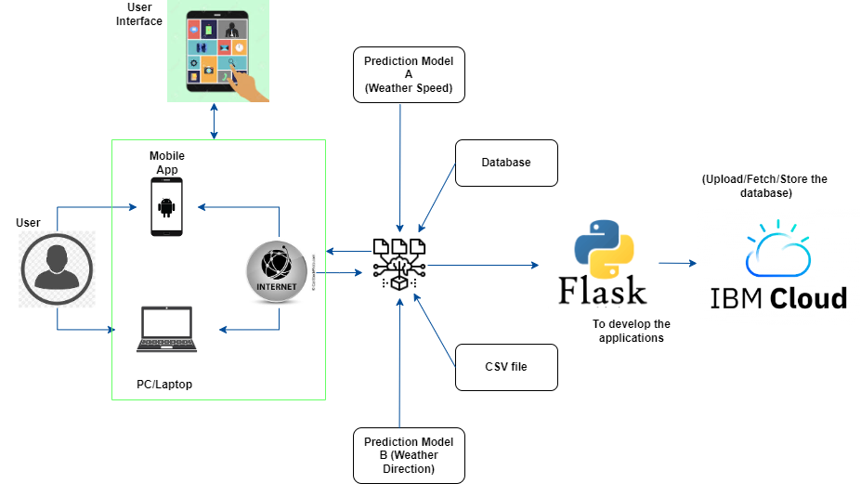

**ADVANTAGES**

* Generating energy from the wind does not release any carbon emissions. By replacing electricity generated from other sources such as fossil fuel power stations, wind energy can lead to an overall reduction in carbon emissions.
* The energy used in manufacturing and installing wind turbines can also be paid back relatively quickly. For a large wind turbine on a good site this can be as quick as six to eight months.
* It is a very clean energy source, which does not release any pollution or produce any waste during operation.
* The energy output of a wind farm is highly dependent on the weather conditions present at its site. If the output can be predicted more accurately, energy suppliers can coordinate the collaborative production of different energy sources more efficiently to avoid costly overproduction.

**RESULTS**

**INTRO PAGE:**

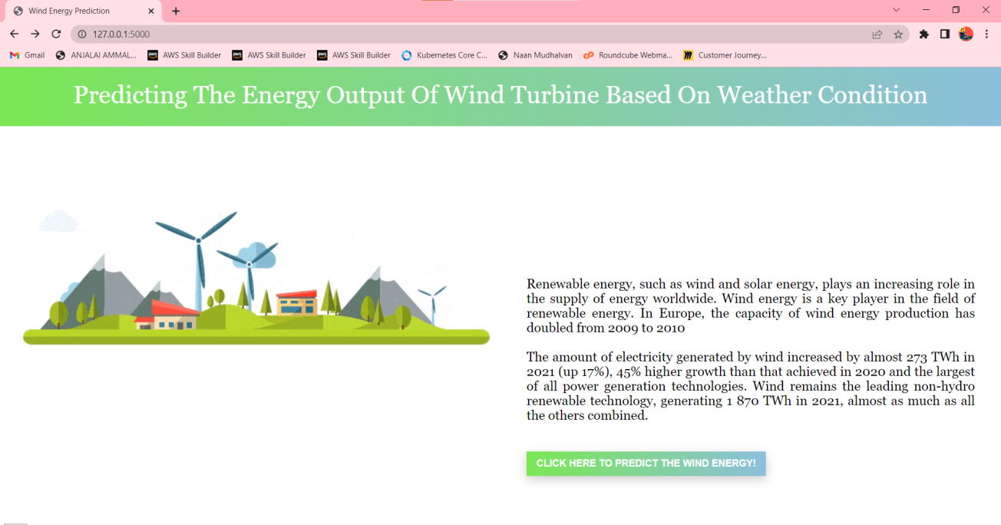**PREDICTION PAGE:**

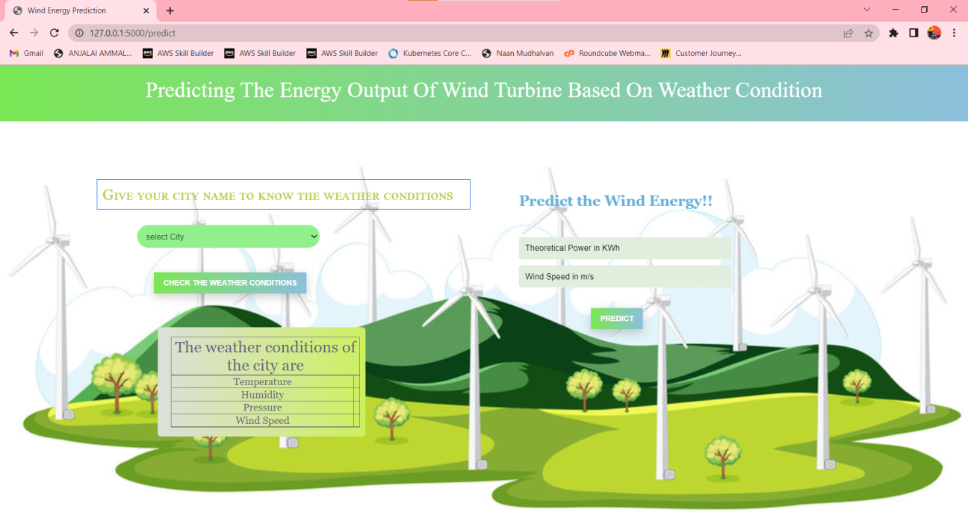

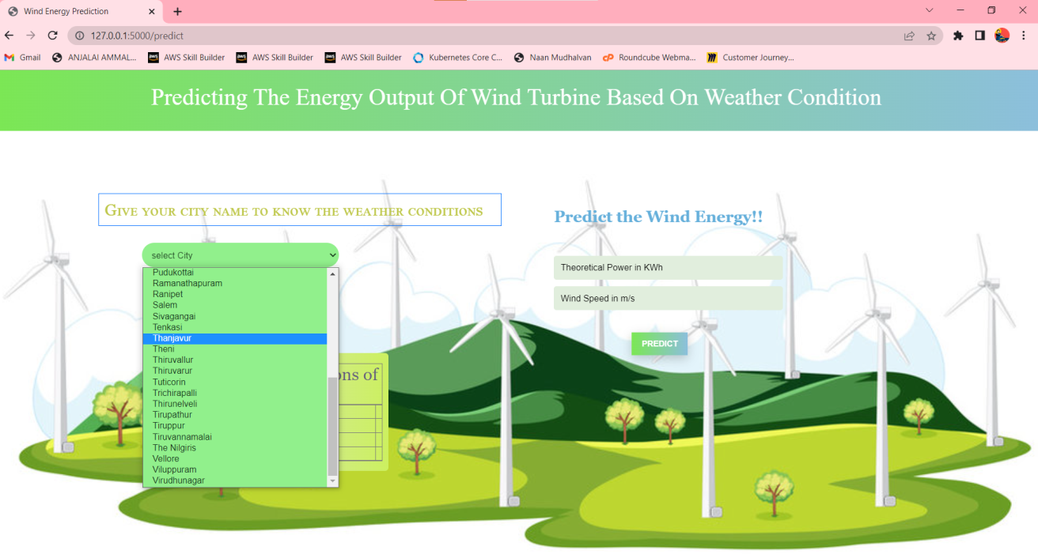

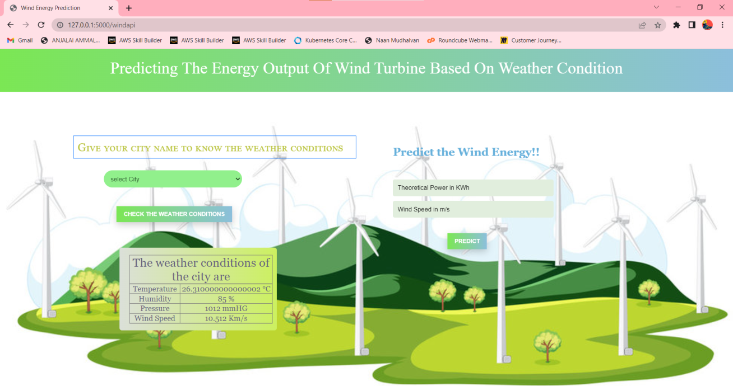

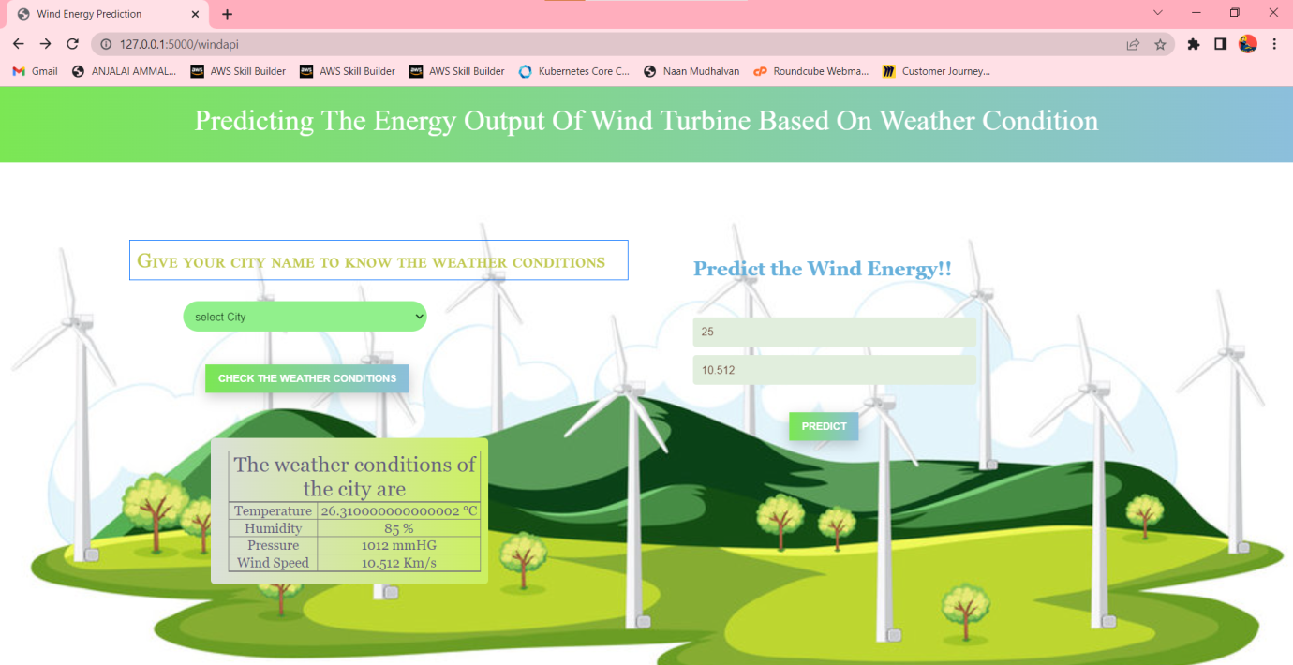

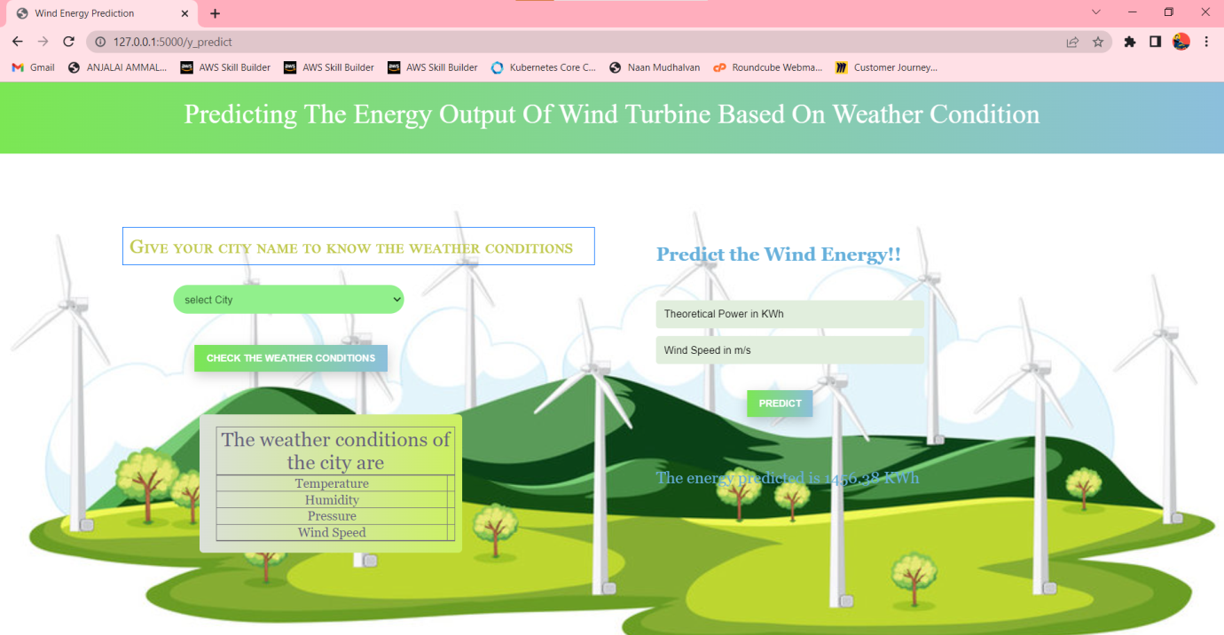

**FUTURE SCOPES**

* Despite our model giving good results, we can add robustness to it by making it do the predictions for a greater time in the future.
* Our model can be scaled by governments by training our model with their data with better enhancements.
* Features like humidity and climatic changes should be considered to achieve better predictions.

**CONCLUSION**

Thus accurate wind power forecasting plays a key role in dealing with the challenges of power system operation under uncertainties in an economical and technical way.

This unique approach would surely open up new avenues and make wind farm data more reliable and precise.

In our application only weather parameters are considered.

More updations can be done in the future if the application needs requirements.

Hopefully, the power of Machine Learning would boost the mass adoption of wind power and turn it into a popular alternative to traditional sources of electricity over the years.

**APPENDIX**

**APP.PY**

import numpy as np

from flask import Flask, request, jsonify, render_template

import joblib

import requests

app = Flask(__name__)

model = joblib.load('Power_Prediction.sav')

@app.route('/')

def home():

return render_template('intro.html')

@app.route('/predict')

def predict():

return render_template('predict.html')

@app.route('/windapi',methods=['POST'])

def windapi():

city=request.form.get('city')

apikey="88d9c0f472a2dc46dc4a1f2d58f1d9d0"

url="http://api.openweathermap.org/data/2.5/weather?q="+city+"&appid="+apikey

resp = requests .get(url)

resp=resp.json()

temp = str((resp["main"]["temp"])-273.15) +" °C"

humid = str(resp["main"]["humidity"])+" %"

pressure = str(resp["main"]["pressure"])+" mmHG"

speed = str((resp["wind"]["speed"])*3.6)+" Km/s"

return render_template('predict.html', temp=temp, humid=humid, pressure=pressure,speed=speed)

@app.route('/y_predict',methods=['POST'])

def y_predict():

'''

For rendering results on HTML GUI

'''x_test = [[float(x) for x in request.form.values()]]

prediction = model.predict(x_test)

print(prediction)

output = prediction[0]

return render_template('predict.html', prediction_text='The energy predicted is {:.2f} KWh'.format(output))

if __name__ == "__main__":

app.run(debug=False)